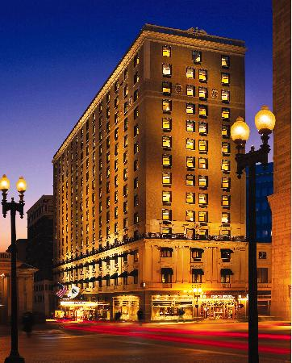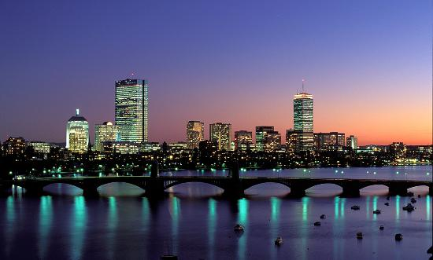

The restaurant we could go to is Tasty Burger. When you go to Tasty Burger, it’s like in another world. Their burgers are so tasty that when you take your first bite out of the burger you’re going to be in love with the burger.

November 22, 2013

Jet Blue Flight: 56

Departs Dulles: 9:47am

Arrives Boston: 11:11am

November 24, 2013

Jet Blue Flight 1257

Departs Boston: 11:47am

Arrives Dulles: 1:30pm

Total Cost of Flight for 3 people: $955

Flight Information

November 22-24, 2013

I found a really nice hotel that we can stay in when we go to Boston. It is called Omni Parker House. The hotel has so many things that you would love like wine, chocolate dipped strawberries and a queen sized bed. I am already comfy.

/

# Tasty Burger

#### Omni Parker House

# The Hearn Family Get Away

**Boston, Massachusetts**

# Odyssey Cruises

I found a fun place where we can hang out. It’s called Kings Lanes, Lounge, and Billiards. We can do lots of stuff at that place like bowling, hang out and even relax on a couch. That seems like a fun time a fun time.

# Odyssey Cruises

I know you’ve been on a cruise before but this one is all about relaxing and having fun. There you can relax in the swimming pool or you can relax in the sizzling hot tub. I am totally going in the hot tub.

# Sky Zone Indoor Trampoline Park

Remember when I said that Kings Lanes, Lounge and Billiards was fun? Well this place is 100 times better. This place is called Sky Zone Trampoline Park.

# Blue Man Group

I have never seen the Blue Man Group before. I heard that if they hit their instruments colors explode out of the instruments. Oh no I think my mind just exploded with colors.

# New England Aquarium

#### Activities

This aquarium will blow your mind. There are so many awesome animals in this aquarium. This aquarium is called the New England Aquarium. The animals that are in the aquarium are a octopus, a sea lion and even a green sea turtle.