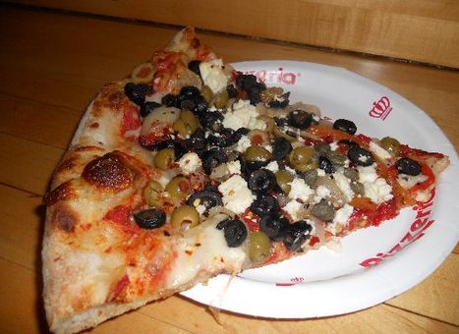 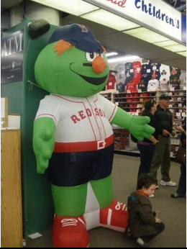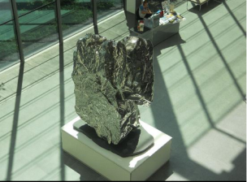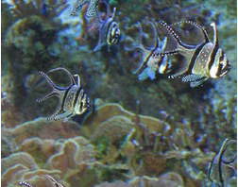

There is any type of pizza here! Anything from just plain cheese to Hawaiian! This is the pizza place for us. It has great pizza and is very family friendly. Let’s go here!!

November 22, 2013

Jet Blue Flight: #56

Departs Dulles: 9:47am

Arrives Boston: 11:11am

November 24, 2013

Jet Blue Flight #457

Departs Boston: 11:47am

Arrives Dulles: 1:30pm

Total Cost of Flight for 5 people: $1,840

Flight Information

November 22-24, 2013

On the ground floor there is an indoor pool, which is perfect for us because our family loves to swim! Inside the room is a Keurig K-cup coffee machine. They have granite countertops in the bathroom so that if we have a coffee spill (mom and dad) we can wipe it off without any hassle. There is also a outdoor seating area to just sit and relax and maybe drink your coffee. To top it all off there is a water view outside most of the windows in the room.

# Pizzeria Regina

#### Seaport Boston Hotel

# Keating Family Get Away

**Boston, Massachusetts**

# Museum of Fine Arts

Kids (under 17) are free! Adults are $25. I know what you are thinking what time should we leave for lunch? Well, no problem there is a Garden Café there; which has good, fair prices.

# Neiman Marcus

Time to go indoor window shopping! This store has anything you can imagine from sneakers to wedges to leather jackets! Don’t worry dad, I have something that might appeal more to you, but how could you beat going shopping with us!

The Red Sox Team Store

**New England Aquarium**

This aquarium is so cool; it has a green anaconda, a giant pacific octopus, and the American lobster! That’s only a few of the hundreds of things there are at this aquarium.

Neiman Marcus: Window Shopping

A

#### Activities

# Museum of Science

Let’s talk admission first, adults are $23. A kid 3-11 is $20 so not the cheapest, but is a lot of fun! This museum is awesome. You can visit the Cahners Computer Exhibit where you can think like a computer and operate a robot!

# Red Sox Team Store

Let’s visit the Red Sox Team Store! It got so many great reviews! It also has anything from bracelets to jerseys to beard t-shirts! Let’s move on!