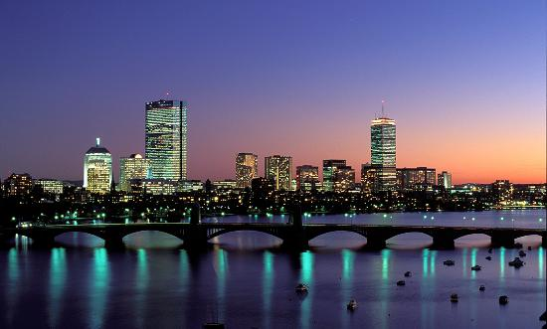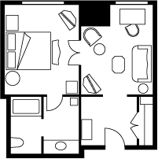

November 22, 2013

Jet Blue Flight: 56

Departs Dulles: 9:47a

Arrives Boston: 11:11a

November 24, 2013

Jet Blue Flight 457

Departs Boston: 11:47am

Arrives Dulles: 1:30pm

Total Cost of Flight for 4 people: $1480

Flight Information

November 22-24, 2013

Here we can stay at a five star hotel called The Boston Harbor Hotel! Here early in the morning we can look out on the Atlantic Ocean that is emerald green, and then in the evening after all the activities we can look at the fiery red sun set under the waves. Also stay in a two room, four room, even five room suite which accommodate king, queen, and double beds with accommodations of lavish furniture.

# Atlantic Fish Company

#### Boston Harbor Hotel

If we leave the hotel and ride to Atlantic fish co. we will ***HAVE*** to stay for seconds. They serve cuisines like Florida swordfish steak or Nova Scotia halibut! Some cuisines! They also have Costa Rican Mahi Mahi! (I prefer the Nova Scotia Halibut for brunch.) For dinner, Atlantic cod and haddock! Don’t forget the Yellowfin tuna steak and desserts! Some desserts are red velvet cakes or Vanilla Crème Brulee.

# Horne Family Get Away

**Boston, Massachusetts**

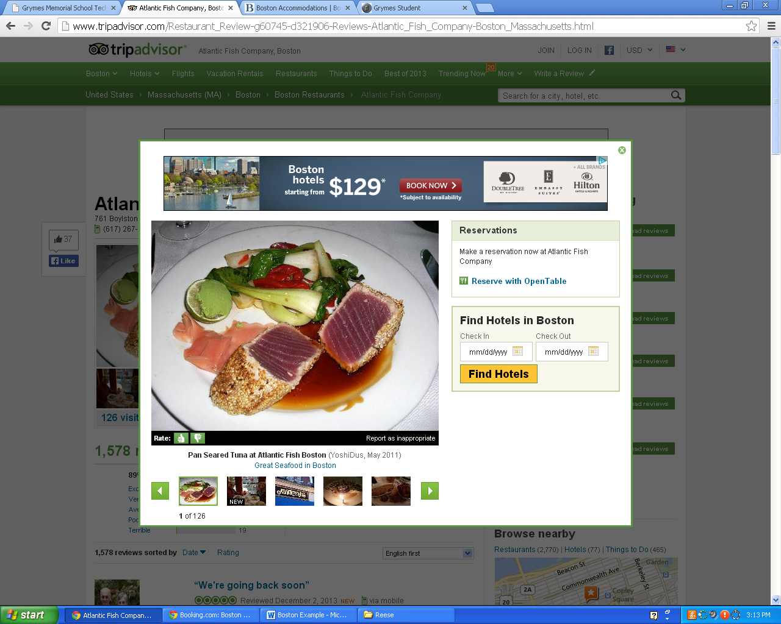

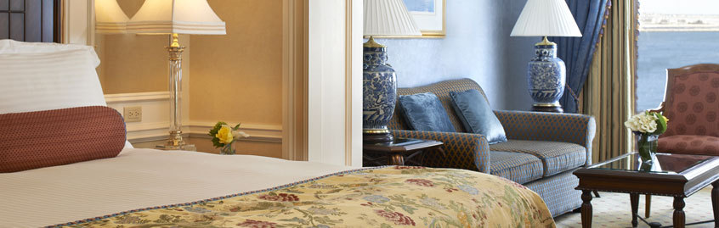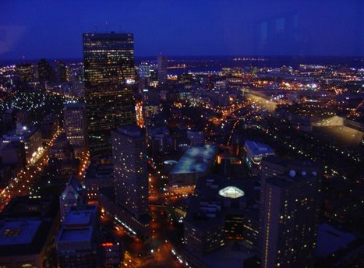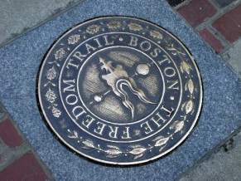

# Sky Zone Indoor Trampoline Park

Sky zone is awesome! You can let kids play there while you go do something else. On the outside it might look like a dinky building but on the inside it is trampoline madness! (not really)

# USS Constitution

Here we can experience what it was like to be on the high seas! We can unfurl a sail, fire a cannon, scrub the decks, and take a tour both on and off the ship! Look at real artifacts from the ship, a real cannon, for instance, or a cannonball. Then take another tour through its memory lane (history).

# Museum of Science

Here we can take a relaxing tour of Persian pots and electricity conductors and much, much more from the 19th century. Then in its study hall we can look at books.

# Waterfront

When we are about too tired out after the Freedom Trail we can grab a picnic and walk on over to the Waterfront and rest in fresh sunbeams, have a picnic, and even a relaxing stroll. Anything to just relax.

Boston at night

# Freedom Trail

Soon after, we’ll get to see a lot of historical sites and Boston’s great architectural achievements! Such as Quincy Market, Faneuil Hall, Boston Common, The North End, Paul Revere's House, USS Constitution and a lot more.

#### Activities