#### Sheraton Philadelphia Society Hotel

November 22, 2013

United #3331

Departs Dulles 8:24 am.

Arrives Pennsylvania 9:24am.

November 24, 2013

United 3339

Departs Pennsylvania 6:15 am.

Arrives Dulles: 7:13 am.

Total Cost of Flight for 5 people: $3,160

Flight Information

November 22-24, 2013

# Vernick Food and Drink

# Holliday family trip

**Philadelphia PA**

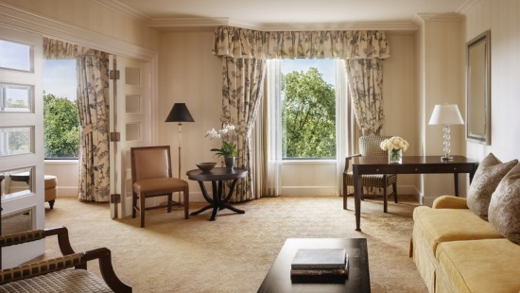

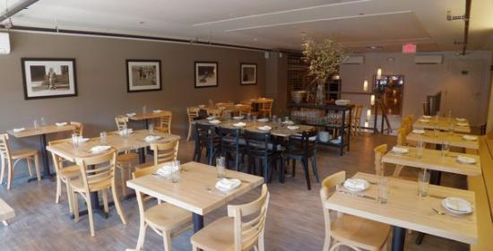

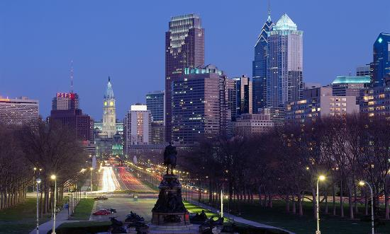

I picked this restaurant because it has great food like carrot cake and for an entree there is Maryland crab. The price is low and the food is great.

I picked this hotel because the walls are amazing. There is a swimming pool and a hot tub for you mom. The hotel is a 4.5 star hotel.

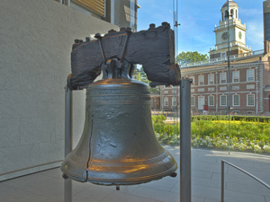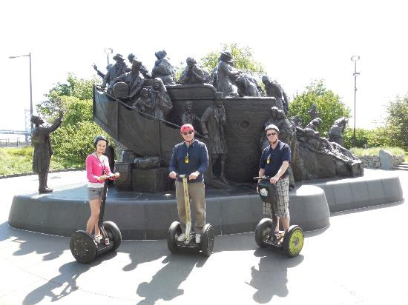

# The Liberty Bell

# Smith Kids Place [playground and Mansion

This place is a cool place for Josh and I. Mom, you can go shopping with Chas while Josh, Dad, and I play here.

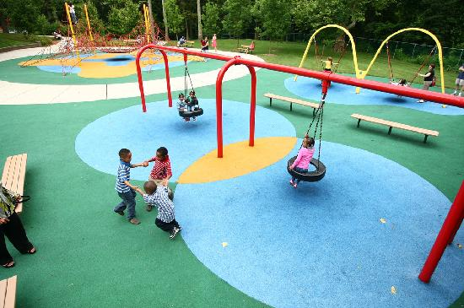

# Philly by Segway

If you are tired we can ride around on a Segway and see the whole city. You get to go to historical places and statues.

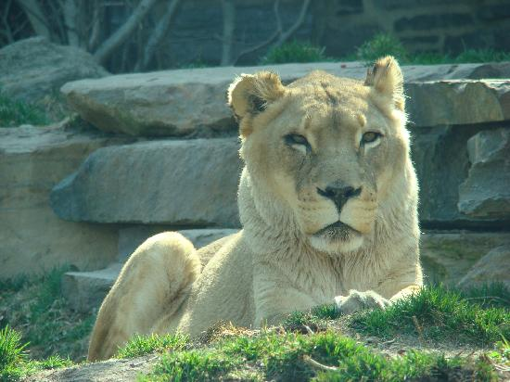

# Philadelphia Zoo

The zoo is an amazing place to see animals. You can see lions and other animals.

**You know that I have been begging to go there my whole life. Here is a fact about the liberty bell- it is a bell that cracked during a test run in 1840.**

#### Activities