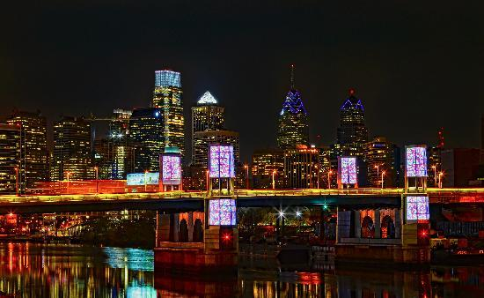 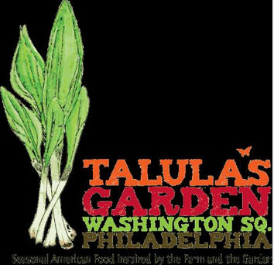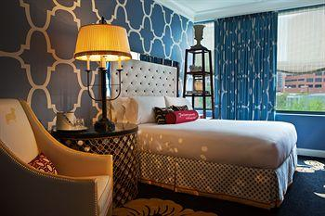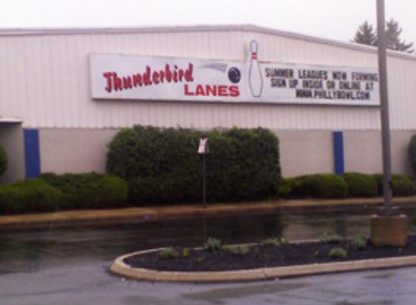

November 22, 2013

United Flight: 3331

Departs Dulles: 8:24a

Arrives Philadelphia: 9:24a

November 24, 2013

United Flight 3339

Departs Boston: 6:15a

Arrives Dulles: 7:13a

Total Cost of Flight for 5 people: $3360

Flight Information

November 22-24, 2013

I picked Talula’s garden restaurant because our family loves eating Italian food. At Talula’s Garden there is yummy pizza. There are also cookies and milk.

I can’t wait for you to see this hotel. Each room at Hotel Monaco has a flat screen tv. For you mom and dad there is coffee and tea every morning. Hotel Monaco is a two minute walk from the Liberty Bell.

# Talula’s Garden

#### Hotel Monaco

# Simmonds family trip

**Philadelphia, PA**

#### Activities

# Please Touch museum

At the Please Touch Museum Dad, Nile, and I can play a bunch. There are many hands on things.

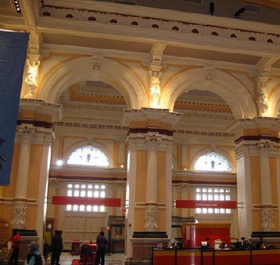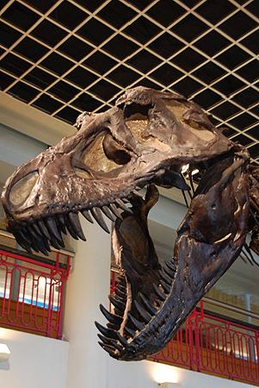

# Rave Motion Pictures

We can watch new movies here. The theaters are very clean. We can eat yummy popcorn.

Dinosaur bones at the Academy of Natural Sciences of Drexel University

# Thunderbird Lanes

Wouldn’t a bowling lane be fun? We have to visit Thunderbird Lanes. We can also keep score.

# Independence National Historical Park

At this national park we can see the Liberty Bell. We can also go inside the Independence Hall. It is the place where the constitution was signed.

# Academy of Natural Sciences of Drexel University

Here we can see dinosaur bones. There is a butterfly garden indoors.