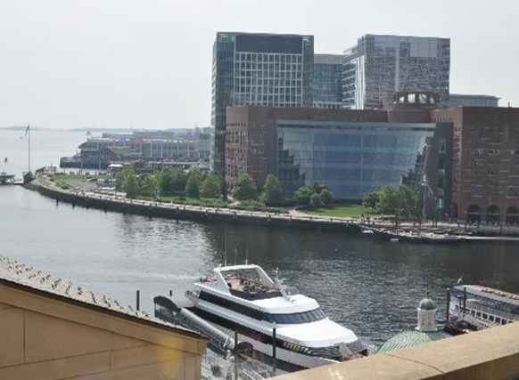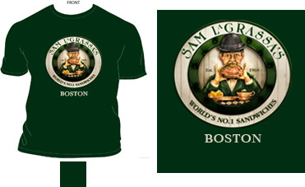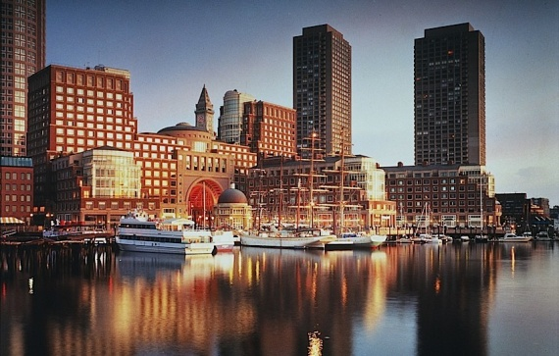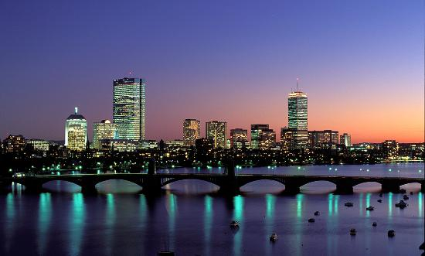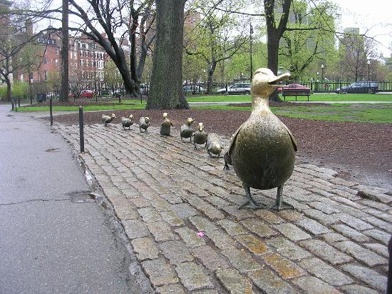

The Boston Harbor Hotel looks like a fun hotel because it is by the water. Mom, the Boston Harbor Hotel has very large rooms. Dad, the hotel has a big gym. I could swim in the swimming pool.

Sam Lagrassas looks awesome because it has the number one sandwiches in Boston. Mom, Sam Lagrassas has complimentary salads. Dad, it has very big steaks too. It is also the number 1 restaurant in Boston.

November 22, 2013

Departs Dulles: 9:47a

Arrives Boston: 11:11

November 24, 2013

Departs Boston: 6:35p

Arrives Dulles: 8:16p

Total Cost of Flight for 3 people: $1,119

Flight Information

November 22-24, 2013

# Sam Lagrassas

#### Boston Harbor Hotel

# Eddy Family Get Away

**Boston, Massachusetts**

# Boston Public Gardens

We have to visit the Boston Public Garden because it was ranked the 7th best park in America by the Trip Advisor website. If the weather is good, we can take a swan boat and feed the ducks. We don’t want to miss the “Make Way for Ducklings” statue. The park will be a nice place to relax after a busy day in the city. Mom, you can run around the park.

# Boston State House

Going to the Boston state house will be fun for all with history. With its great artifacts, it is one of the most historic places in Boston.

# Boston tea party museum

The Boston tea party museum is a must go to place (if you like tea). Mom, you could push a fake box of tea over a rail. Dad, we could look at the artifacts.

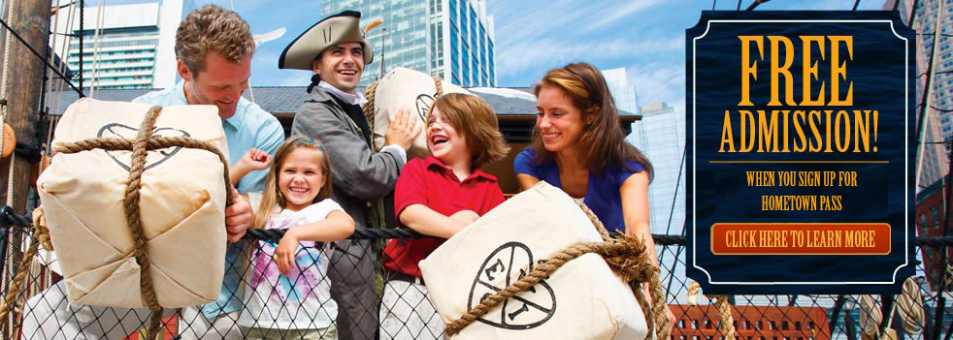

# New England aquarium

Because we like to see fish we will have a blast here. Mom, you can watch all the cute penguins. Dad, you could watch seals do funny tricks. I could have fun watching a leafy sea dragon.



# Sky zone

We have to visit sky zone if we have time. With walls that are big trampolines and basket ball nets we are sure to have fun. Mom, you could go shopping.

Boston Public Gardens

Make Way for Ducklings

#### Activities